Read the text and answer the questions.

How do they spread?
It is possible to pick up a computer virus from the internet; there are many ways this could happen:
1. When files are shared with each other, this includes emails.
2. When you go on certain websites which have viruses.
3. Some pop-ups may contain viruses.
4. When you download a file with a virus.

Another way of picking up a virus is to load a file which has a virus into your computer from a storage device, examples of storage devices are:
• memory stick
• CD ROM
• DVD

Note: This does not include CDs and DVDs you buy from a shop, it is the ones that you create yourself which could be a problem. You might not know your computer has a virus, until something goes wrong.

Questions
- List 2 ways a virus can be picked up from the internet.

2. Name the three storage devices which could contain a virus.
• ………………………………………………………………………………………………
• ………………………………………………………………………………………………
• ………………………………………………………………………………………………

3. Do you always know you have a virus straight away?

4. Can you think of any other ways you could pick up a virus?

Read the text and answer the questions

How can they be removed?
'Anti-virus software' is created to identify and remove viruses. There are a number of anti-virus programs available for removing viruses for example Norton, McAfee and Sophos. When the anti-virus software recognises a virus, it will tell the user, and ask them if they want to remove the virus and clean the system, or if they just want to 'quarantine' the virus, this means the virus is put in a place away from all other files. These software’s are updated regularly to fight against new viruses.

A disadvantage to using anti-virus software is when installing a new software/program on the computer, it can be very awkward as the anti-virus software 'thinks' that the new software/program itself is a virus. This is because when it is installed, it goes into various locations on the computer. This is why when installing a new software/program, you should turn the anti-virus software off.

Questions
- What is anti-virus software?

- Give one example of anti-virus software.

- Fill in the blanks When the _ _ _ _-_ _ _ _ _ software _ _ _ _ _ _ _ _ _ _ a virus, it will tell the user, and ask them if they want to _ _ _ _ _ _ the virus and _ _ _ _ _ the system, or if they just want to '_ _ _ _ _ _ _ _ _ _' the virus. ….

- Can you think of an advantage of using anti-virus software?

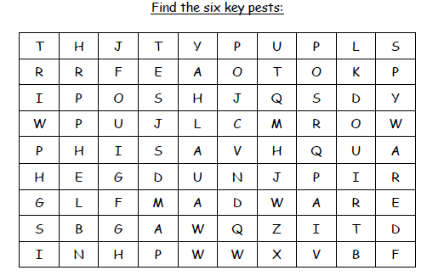
Spam
Phishing
Trojan
Adware
Spyware:
Worm

