- Look at the following advert for a computer system
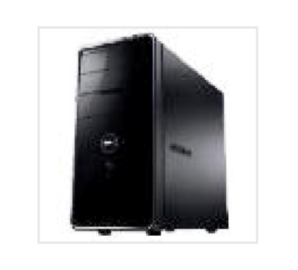
a) How much memory does this computer come with?
…............................................................................................
 | …............................................................................................ | [1]
b) | Name 1 piece of software that is included with the computer.  …............................................................................................
 | …............................................................................................ | [1]

3. Paul takes his computer to a local computer shop complaining that it is too slow when playing games. The computer has an 800MHz processor, 512MB of RAM, a CD-ROM drive and a 40GB hard disc.
- Explain the purpose of RAM.
…...............…....…......................................................................................
…...............…....…......................................................................................
…...............…....…......................................................................................
…...............…....…...................................................................................... [3]
- Suggest two components Paul could upgrade to make his computer run faster and explain how it will make the computer run quicker:
Component:
Reason:

Component
Reason:
[4]
4. Phyllis is learning about the CPU
- Explain the purpose of the CPU.
…...............…....….........................................................................................
…...............…....….........................................................................................
…...............…....…........................................................................................ . [2]
- Explain why increasing each of the following will make a computer system faster.
  - Clock speed.
…...............…....…....................................................................................................................
  - Cache size.
…...............…....…....................................................................................................................
  - Number of cores.
…...............…....…........................................................................................................................ [3]
5.
- Give 2 differences between RAM and ROM.
  - …...............…....…................................................................................... ii.…...............…....….................................................................................. . [2]
- A computer system has an 8MB cache and 2GB of memory.
  - Does the computer have more cache or more memory?
…...............…....…...................................................................................
  - Explain the purpose of the cache
…...............…....…...................................................................................
…...............…....…...................................................................................
  - Explain what is meant by “Virtual Memory”
…...............…....…...................................................................................
…...............…....…....................................................................................
………………………………………………………………………………………[3]

