Introduction to Python
Over the next couple of lessons you’re going to learn how to program in a language called Python.
Open up Python

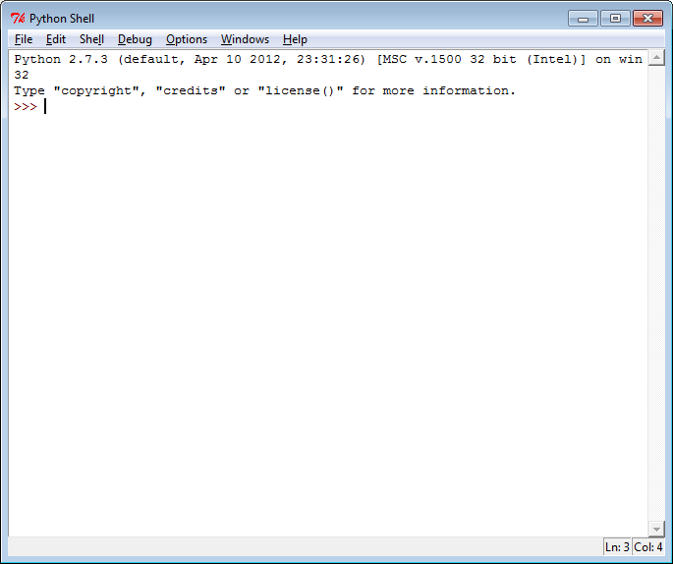
Type in the following and press enter 2 + 2
What happens?

What do you think will happen if the following is typed into python?
9-3
2*4
10/2
3**2

Try them out and see if your predictions were right.

VARIABLES
myBox
4
Variables are locations that we can use to store data in. Think of it as box in which we can temporally store data in.
Typing myBox = 4 will create a variable called myBox and store the number 4 in it.
To show what is currently being stored in myBox we need to use the print command which will print the data (on to the computer screen).
Type in these lines of code exactly as the appear and write down what happens
myBox = 4
print myBox
myBox + 2
myBox * 5
myBox = 8
print myBox
print mybox

For the last line you should have got an error. This is because python is cAsE sEnSiTiVe which means that the program doesn’t treat myBox as being the same as mybox!
Predict what will happen if you type these lines of code into python
myBox = 8
print myBox
myBox =myBox +1
print myBox
myBox =myBox + myBox
print myBox
apples = 2
pears =3
myBox = apples + pears
print myBox

All the numbers used have been whole numbers which are also known as INTEGERS. There are many other data types which we will use in computing.
Data Type | Definition | Examples
Integer (called int or long in Python) | A whole number. | 1, 5, -63, 247
Float | A number with a decimal point | 1.5, 3.14159, -0.47, 2.0
String | A block of text (designated with ‘ marks in Python). Any numbers contained within a string are treated as text and cannot be used in calculations | ‘Python’, ‘ICT’, ‘Hindley High’, ‘3’
Array (called List in Python) | A list of data stored in a structured way. Represented with [ ] in Python and values separated with a comma. | [‘Python’, ‘programming’, ‘is’, ‘awesome’]  [‘English test’, 48, ‘C’]
Comment | A comment in the code which is ignored by the computer. Starts with # in Python. Useful for leaving instructions | # This line creates a string call test  # creates a variable called myBox
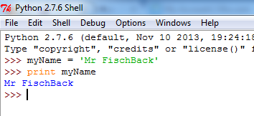
Type the following into Python.
myName = ‘enter your name’
print myName

Type in the following and explain what is happening in each
Type this into Python | What is printed out | What do you think is happening
print myName
print myName [0]
print myName [4]
print myName [2:5]
print myName [3:]
print myName *2
print myName [:4]
Print myName + ‘ is awesome’

Strings in Python
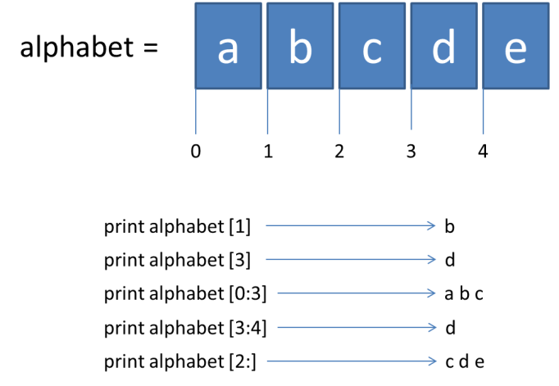

My first Python program
So far all the lines of code have been written directly into the Python Shell. The next task will create and save a python program.
Go to File | New Window (or press Ctrl + N) to open up a new window to write a program in.
Type in the following code
myName = ‘My name is Mr Fischback’ (replace Mr Fischback with your name)
print myName

This time python won’t automatically print the name as the program is not being run. To run the program it needs to be saved and run inside the Python Shell.
Go to Run | Run Module (or press F5). Python will prompt you to save the program. Save it as My First Program in your Year 9 ICT folder.
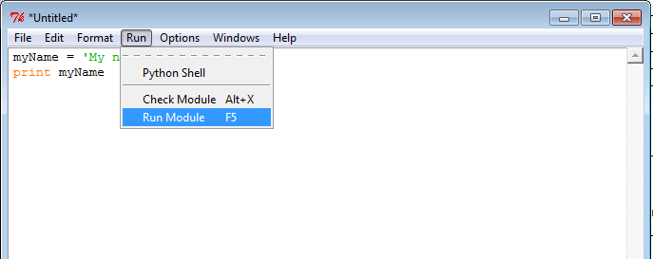
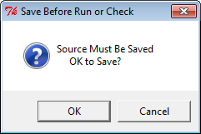
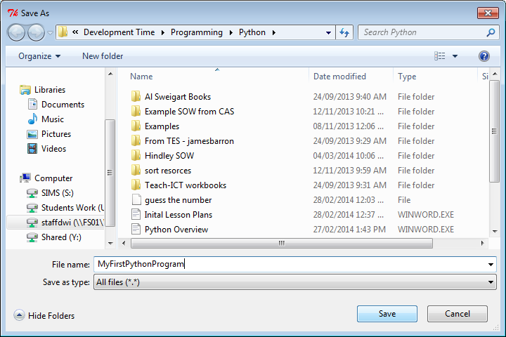

My Second Python Program
Open a new window and type in the following code
myName = 'Bob Marley' # sets the variable myName to the string 'Bob Marley'
print 'My name is ' + myName # prints My name is and the value of myName

Save the program and run it in the Python Shell.
What is printed out this time?

Extension
Edit the program so that it prints the full name and then prints just the first name and just the surname on separate lines.

Example
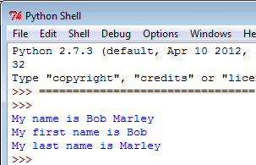

Hint print part of a string by using []

Copy what you typed into here

Input commands
We are going to write a new program to allow anybody to type their name in and the program will great them.
Open a new window in Python and type in the following code.
name = raw_input(‘Please enter your name ‘)
print ‘Hello ‘ + name

Save your code and run it in the Python Shell.
Go back to your code and edit it so that the computer asks the user more questions and then gives a suitable response.
Add some comments to your code using hash tags #.

Write you name at the top of the program using the # and then print it out.

So far we have learnt about
Topic | I can’t do this | I can do this with some help | I can do this on my own
Using the python shell as a calculator
Creating and using variables
Using integers
Using strings
Using a new window to create a program
Using comments to add notes to your program
Manipulating a string so that only part of it is printed out
Using the raw_input command to prompt users to input information
Tick off how confident you feel about the topics we have covered so far

