Computer Science
  - Homework Booklet

Name
Teacher
Target Grade

Module results
1 | 2 | 3 | 4 | 5


Before you start

Programming in Python

The development of programming skills is very important in GCSE Computing. Therefore, it is recommended that you practise these skills at home by downloading the Python software for free. It can be found at:

https://www.python.org/download/releases/3.0/

You may also want to download the IDE PyScripter, which is also free, from:

https://code.google.com/p/pyscripter/

There are several good websites that have tutorials to help you develop these skills. They can be found at:

http://www.learnpython.org/

http://www.codecademy.com/tracks/python

Homework 1

- Label the internal hardware components below using the key words provided. (6 marks)

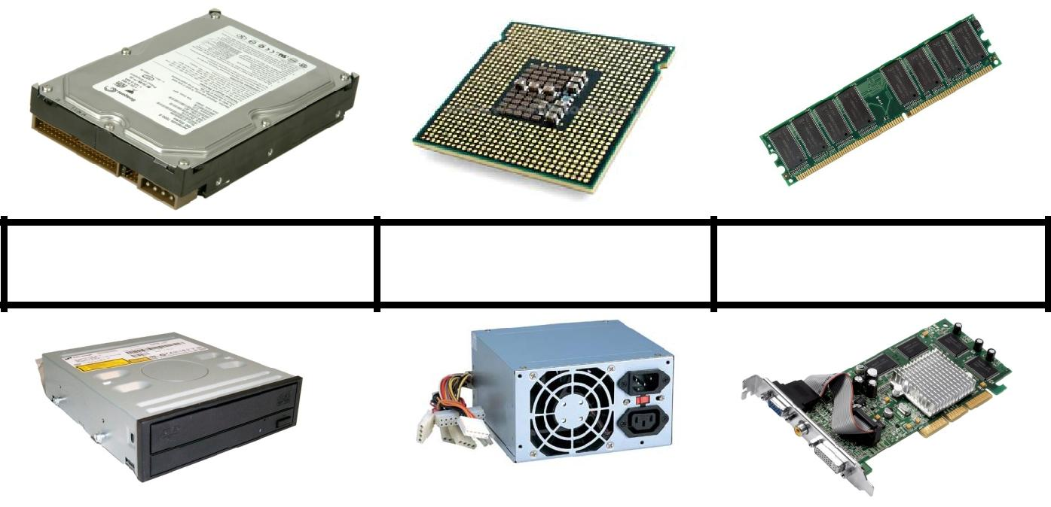

Power Supply Unit | Random Access Memory |  | Central Processing Unit
 |  | (RAM) | (CPU)
CD/DVD Drive | Hard Disk Drive (HDD) |  | Video Card

2. Explain the purpose of each device above. (12 marks)

Device | Purpose
RAM
CPU
CD/DVD Drive
Hard Disk Drive
Video Card

Homework 2

- The picture below shows a PC typically found in the home. Identify the input and output devices shown in the picture below. (4 marks)
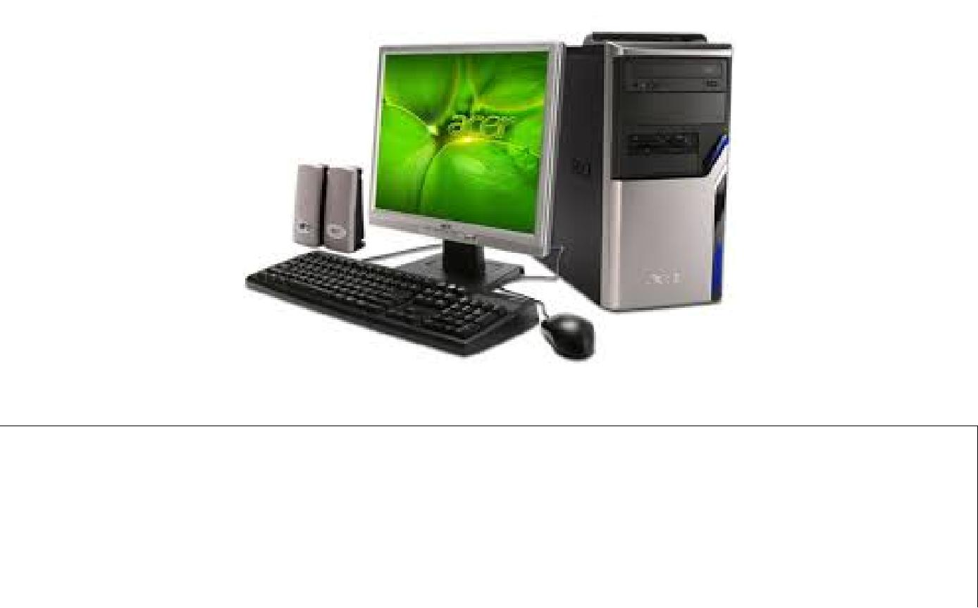

Input Devices Output Devices

- A secondary school wants their computers to be more accessible to students with disabilities. Describe, with examples, input and output devices which are available for students with disabilities. (6 marks)

..........................................................................................................

..........................................................................................................

..........................................................................................................

..........................................................................................................

..........................................................................................................

..........................................................................................................

..........................................................................................................

Homework 3

- For each of the secondary storage devices listed below, identify the type and give an advantage and disadvantage. (12 marks)

Storage Device Type (Magnetic, Advantage Disadvantage

Optical, Solid state)

CD-ROM

Hard Disk

Drive

Flash Drive

Floppy Disk

Homework 4

- Using the internet, research a specification for two personal desktop computers. One machine should be cheap and the other expensive. (6 marks)

Cheap Computer | Expensive Computer

Make

Cost

CPU Type

CPU Clock Speed

CPU Cache Size

RAM

Hard Drive Capacity

Video Card

- For each specification above, identify their potential uses e.g. word processing, gaming, business use, browsing the internet etc. (4 marks)

Cheap Computer .......................................................................................

.................................................................................................................

.................................................................................................................

Expensive Computer ..................................................................................

.................................................................................................................

.................................................................................................................

Homework 5

- Mary has bought the cheap computer (from Homework 4). She is using the machine mainly for gaming and thinks it is too slow for the types of games she likes to play.

Explain two ways by which the computer can be upgraded to improve its performance. (4 marks)

.................................................................................................................

.................................................................................................................

.................................................................................................................

.................................................................................................................

.................................................................................................................

.................................................................................................................

.................................................................................................................

.................................................................................................................

.................................................................................................................

.................................................................................................................

Homework 6

- Research and make notes on John von Neumann and draw a diagram of his computer architecture. (10 marks)

.................................................................................................................

.................................................................................................................

.................................................................................................................

.................................................................................................................

.................................................................................................................

.................................................................................................................

.................................................................................................................

.................................................................................................................

.................................................................................................................

.................................................................................................................

Computer Architecture

Homework 7

- Find out how many bits/bytes each of the storage units below represent. (7 marks)

Bit | Nibble | Byte | Kilobyte | Megabyte | Gigabyte | Terabyte
 |  |  | (KB) | (MB) | (GB) | (TB)

2. A kilo means 1000. Why is a Kilobyte not equivalent to 1000? (2 marks)

.................................................................................................................

.................................................................................................................

.................................................................................................................

Homework 8

1. Draw the symbol that represents the following logic gates. (3 marks)

NOT Gate

AND Gate

OR Gate

Homework 9

1. Complete the following logic circuits by filling in the blanks. (5 marks)
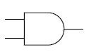

1 | 1
.... | 1
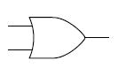

1
....
0
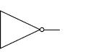

.... |  | 1
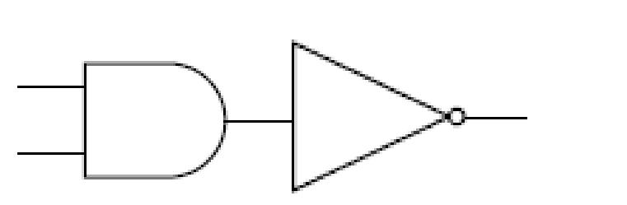

1 | ....
1 | ....
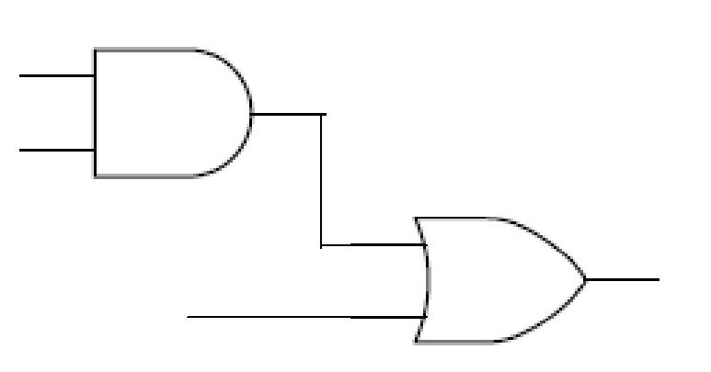

0

1

....
1

Homework 10

1. Create a truth table for each of the logic circuits below.

A | B | P
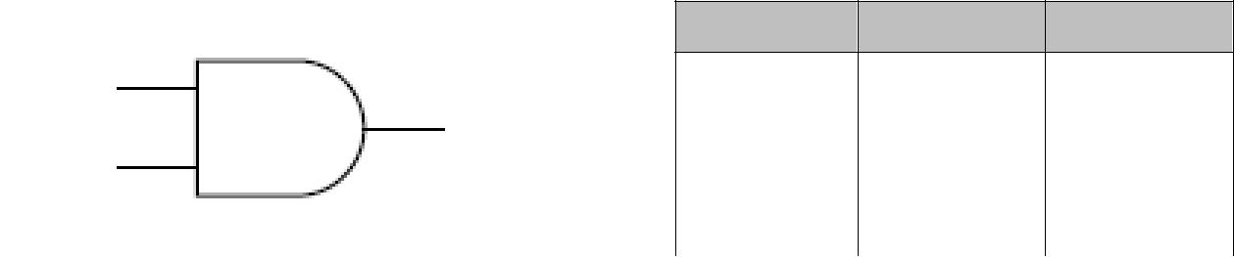
a | p
b | p
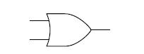

a | p
b | p
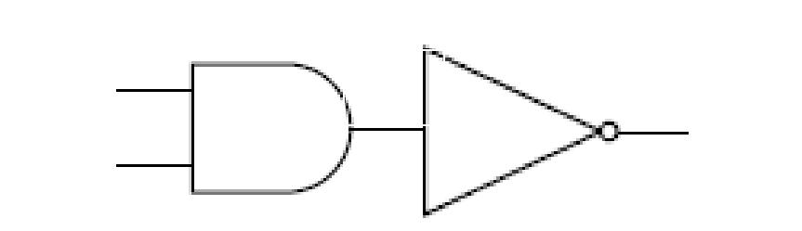

a | r
b | p

A | B | R=A AND B | P=NOT R

Homework 11

1. De Morgan’s law says NOT(B OR C) is the same as NOT(B) AND NOT(C).

a) Draw the logic circuits for each expression above. (4 marks)

NOT (B OR C) |  | NOT(B) AND NOT(C)

- Create both truth tables to prove De Morgan’s law. (10 marks) P=NOT(B OR C)

P=NOT(B) AND NOT(C)

Homework 12

- Convert the number 152 from denary to binary. Show all your workings. (4 marks)

.................................................................................................................

.................................................................................................................

.................................................................................................................

.................................................................................................................

- Convert the number 01101100 from binary into denary. Show all your workings. (4 marks)

.................................................................................................................

.................................................................................................................

.................................................................................................................

.................................................................................................................

3. Explain why computers store data in binary. (4 marks)

.................................................................................................................

.................................................................................................................

.................................................................................................................

.................................................................................................................

Homework 13

- Add the following binary numbers – show all your workings. (4 marks)

  - 1010 + 101

.................................................................................................................

.................................................................................................................

.................................................................................................................

  - 10001 + 11001

.................................................................................................................

.................................................................................................................

.................................................................................................................

- Find out the denary equivalents for both answers above. (4 marks)

.................................................................................................................

.................................................................................................................

.................................................................................................................

.................................................................................................................

.................................................................................................................

.................................................................................................................

Homework 14

- Convert the following hexadecimal numbers to denary and binary. Show all your workings. (8 marks)

  - 1A

  - 35

  - BC

  - 4D

Homework 15

- Spell the word COMPUTING using binary numbers from the ASCII code. (9 marks)

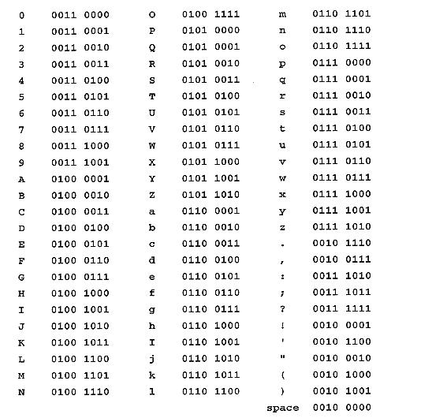

C............................................

O............................................

M............................................

P.............................................

U.............................................

T.............................................

I .............................................

N.............................................

G.............................................

Homework 16

A canteen card payment machine is used in a secondary school. The user has to enter their ID Number and the cashier enters the amount spent on food, if they have above £0.00 credit, the price of their food is subtracted from their credit on their card.

1. Complete the pseudocode for this system below. (8 marks)

INPUT

INPUT

IF THEN

ELSE

PRINT

END

Homework 17

- Using the flow chart, write a program in Python that will solve the problem.

HINT: You will need to use a loop for this.

Solution

.............................................................

.............................................................

.............................................................

.............................................................

.............................................................

.............................................................

Start
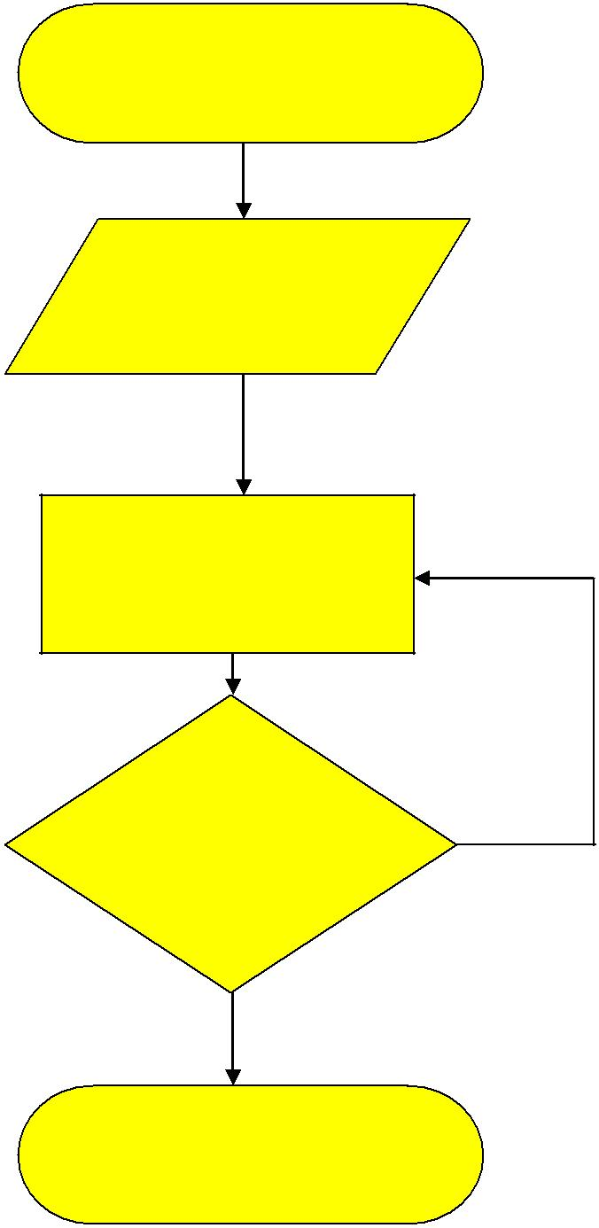

INPUT:

Name

PRINT: A letter of Name

At end of string?

Yes

END

No

Homework 18

- Give a definition for the computer programming key words below. (8 marks)

Word Definition

Constant

Variable

For loop

While loop

Sub-routine

Procedure

Function

If statements

Homework 19

1. Describe each data type listed below and give an example.

Data Type | Description | Example
Integer
Real
Boolean
Character
String

2. What is wrong with the Python code below?

number=input(‘Enter a number to double’) number=number*2

print(‘The answer is ‘ +number)

.................................................................................................................

.................................................................................................................

.................................................................................................................

3. Re-write the code so that it would give a correct answer.

.................................................................................................................

.................................................................................................................

.................................................................................................................

Homework 20

- A list of Python comparison operators has been given below. Describe what each operator does.

Operator | Description
==
!=
>
<
>=
<=

- A list of Python arithmetic operators has been given below. Describe what each operator does.

Operator | Description
+
-
*
/
**
%

Homework 21

- A taxi firm uses a computer to communicate with the office to charge their customers the correct amount. The program in the computer uses sequence, selection and iteration. (3 marks)

State whether the operations below use sequence, selection or iteration. (3 marks)

Performing a series of set-up tasks when the computer is switched on.

.................................................................................................................

Beeping repeatedly after a message is sent, until the driver presses a button to show that the message has been read.

.................................................................................................................

Deciding the use DayTimeRate or EveningRate functions to decide how much to charge the customer.

.................................................................................................................

2. Explain what sequence, selection and iteration mean. (6 marks)

Word Meaning

Sequence

Iteration

Selection

Homework 22

1. Explain what the following utility programs do. (6 marks)

Utility Program Explanation

Anti-Virus

Spyware protection

Firewalls

Homework 23

- Research the types of software listed below. Give a definition, an advantage, disadvantage and an example of each. (16 marks)

Software Description Advantage Disadvantage Example

Type

Off-the-shelf

Custom written

Proprietary

Open source

Homework 24

- ComputaSave is a discount computer retailer. They are planning to introduce an electronic stock management system to control how much of each computer they have in stock. ComputaSave decided to buy a custom written software package that meet the needs of their online and in-store business.

Do you agree with ComputaSave’s decision to use custom written software? Justify you view. (6 marks)

.................................................................................................................

.................................................................................................................

.................................................................................................................

.................................................................................................................

.................................................................................................................

.................................................................................................................

.................................................................................................................

.................................................................................................................

.................................................................................................................

.................................................................................................................

.................................................................................................................

.................................................................................................................

.................................................................................................................

Homework 25

1. Match the key term to the correct definition. (6 marks)

Attribute

Entity Relationship

Diagram (ERD)

One-to-many

One-to-one

Entity

Many-to-many

Describes the facts, details or characteristics of an entity.

Describes a table in a database which is about a person, object or thing.

This shows the relationship between entities.

A type of relationship where there is only one corresponding record in another table.

A type of relationship where there are none, one or any number of corresponding records in another table.

A conflicting type of relationship that cannot be implemented using DBMS software.

Homework 26

1. Study the data in the table below.

Pupil |  | Name |  |  | DOB |  |  | Option Taken |  |  | Type |  |  | Grade
No.
6 |  | T Lyons |  | 5/7/92 |  |  |  | Computing |  |  | GCSE |  |  | A
6 |  | T Lyons |  | 5/7/92 |  |  |  | Business Studies |  |  | GCSE |  |  | B
6 |  | T Lyons |  | 5/7/92 |  |  |  | Engineering |  |  | BTEC |  |  | Merit
2 |  | D Smith |  | 1/2/90 |  |  |  | Computing |  |  | GCSE |  |  | B
2 |  | D Smith |  | 1/2/90 |  |  |  | Food |  |  | GCSE |  |  | C

Answer the following questions using the key words below.

a) What is the problem with the way in which this data is stored

.................................................................................................................

.................................................................................................................

- Explain how the integrity of the data could be compromised.

.................................................................................................................

.................................................................................................................

- Design an ERD for a relational database to solve these problems.

Key Words
Redundancy | Duplicate | Update | Validation
 | Storage | Delete

Homework 27

- Define the term DBMS. (2 marks)

.................................................................................................................

.................................................................................................................

.................................................................................................................

- Explain how indexed sequential files are searched to find a particular item. (4 marks)

.................................................................................................................

.................................................................................................................

.................................................................................................................

- Analyse the problems with a flat-file database. (6 marks)

.................................................................................................................

.................................................................................................................

.................................................................................................................

.................................................................................................................

.................................................................................................................

Homework 28

1. Computer technology has changed the ways in which teenagers interact with each other. Explain how developments in software and hardware have enabled new methods of communication among teenagers. (8 marks)
.................................................................................................................

.................................................................................................................

.................................................................................................................

.................................................................................................................

.................................................................................................................

.................................................................................................................

.................................................................................................................

.................................................................................................................

.................................................................................................................

.................................................................................................................

.................................................................................................................

.................................................................................................................

.................................................................................................................

.................................................................................................................

.................................................................................................................

Homework 29

- Design a program that asks a usero enter a password and then checks the length of the password. If the password is less than 5 characters, it should display a message saying that the password is too short. If the password is the correct length then it should check that there is at least 1 uppercase letter and 1 lowercase letter in the password. If it does not have an uppercase and a lowercase letter it should display ‘weak password’ and if it has both it should display ‘strong password’.

Design your program using either pseudocode or a flowchart.
Assessment

Grade F

Has knowledge of Computing key terms and can give definitions. Can use and interpret simple models.

Grade C
Has knowledge of a range of Computing key terms and can give definitions.
Apply knowledge well e.g. can select suitable hardware for a user.

Analyses problems – breaks down into smaller parts/gives advantages and disadvantages.

Grade A
Critically evaluate how technology is used by the individual.

Homework 1

Grade: |  | Skills used: | Knowledge | Next Step
Grade: |  |  | Application | Next Step
 |  |  | Analysis
 |  |  | Evaluation
Homework 2
Grade: |  | Skills used: | Knowledge | Next Step
Grade: |  |  | Application | Next Step
 |  |  | Analysis
 |  |  | Evaluation
Homework 3
Grade: |  | Skills used: | Knowledge | Next Step
Grade: |  |  | Application | Next Step
 |  |  | Analysis
 |  |  | Evaluation
Homework 4
Grade: |  | Skills used: | Knowledge | Next Step
Grade: |  |  | Application | Next Step
 |  |  | Analysis
 |  |  | Evaluation
Homework 5
Grade: |  | Skills used: | Knowledge | Next Step
Grade: |  |  | Application | Next Step
 |  |  | Analysis
 |  |  | Evaluation
Homework 6
Grade: |  | Skills used: | Knowledge | Next Step
Grade: |  |  | Application | Next Step
 |  |  | Analysis
 |  |  | Evaluation

Homework 7

Grade: |  | Skills used: | Knowledge | Next Step
Grade: |  |  | Application | Next Step
 |  |  | Analysis
 |  |  | Evaluation
Homework 8
Grade: |  | Skills used: | Knowledge | Next Step
Grade: |  |  | Application | Next Step
 |  |  | Analysis
 |  |  | Evaluation
Homework 9
Grade: |  | Skills used: | Knowledge | Next Step
Grade: |  |  | Application | Next Step
 |  |  | Analysis
 |  |  | Evaluation
Homework | 10
Grade: |  | Skills used: | Knowledge | Next Step
Grade: |  |  | Application | Next Step
 |  |  | Analysis
 |  |  | Evaluation
Homework | 11
Grade: |  | Skills used: | Knowledge | Next Step
Grade: |  |  | Application | Next Step
 |  |  | Analysis
 |  |  | Evaluation
Homework | 12
Grade: |  | Skills used: | Knowledge | Next Step
Grade: |  |  | Application | Next Step
 |  |  | Analysis
 |  |  | Evaluation
Homework | 13
Grade: |  | Skills used: | Knowledge | Next Step
Grade: |  |  | Application | Next Step
 |  |  | Analysis
 |  |  | Evaluation
Homework | 14
Grade: |  | Skills used: | Knowledge | Next Step
Grade: |  |  | Application | Next Step
 |  |  | Analysis
 |  |  | Evaluation
Homework | 15
Grade: |  | Skills used: | Knowledge | Next Step
Grade: |  |  | Application | Next Step
 |  |  | Analysis
 |  |  | Evaluation

Homework | 16
Grade: |  | Skills used: | Knowledge | Next Step
Grade: |  |  | Application | Next Step
 |  |  | Analysis
 |  |  | Evaluation

homework 17

Grade: | Skills used: | Knowledge | Next Step
Grade: |  | Application | Next Step
 |  | Analysis
 |  | Evaluation
Homework | 18
Grade: | Skills used: | Knowledge | Next Step
Grade: |  | Application | Next Step
 |  | Analysis
 |  | Evaluation
Homework | 19
Grade: | Skills used: | Knowledge | Next Step
Grade: |  | Application | Next Step
 |  | Analysis
 |  | Evaluation
Homework | 20
Grade: | Skills used: | Knowledge | Next Step
Grade: |  | Application | Next Step
 |  | Analysis
 |  | Evaluation
Homework | 21
Grade: | Skills used: | Knowledge | Next Step
Grade: |  | Application | Next Step
 |  | Analysis
 |  | Evaluation
Homework | 22
Grade: | Skills used: | Knowledge | Next Step
Grade: |  | Application | Next Step
 |  | Analysis
 |  | Evaluation
Homework | 23
Grade: | Skills used: | Knowledge | Next Step
Grade: |  | Application | Next Step
 |  | Analysis
 |  | Evaluation
Homework | 24
Grade: | Skills used: | Knowledge | Next Step
Grade: |  | Application | Next Step
 |  | Analysis
 |  | Evaluation

Homework | 25
Grade: | Skills used: | Knowledge | Next Step
Grade: |  | Application | Next Step
 |  | Analysis
 |  | Evaluation
Homework | 26
Grade: | Skills used: | Knowledge | Next Step
Grade: |  | Application | Next Step
 |  | Analysis
Homework 27

Grade: | Skills used: | Knowledge | Next Step
Grade: |  | Application | Next Step
 |  | Analysis
 |  | Evaluation
Homework | 28
Grade: | Skills used: | Knowledge | Next Step
Grade: |  | Application | Next Step
 |  | Analysis
 |  | Evaluation
Homework | 29
Grade: | Skills used: | Knowledge | Next Step
Grade: |  | Application | Next Step
 |  | Analysis
 |  | Evaluation

Writing skills

6 mark questions are designed to stretch and challenge students. It is important that you understand how they should be answered. You should structure your answer like this:

1st Paragraph – should explain the key term e.g. give a definition.

2nd Paragraph – should make a point (could be an advantage or disadvantage) and explain the point fully giving an example where necessary.

3rd Paragraph – should make another point (could be an advantage or disadvantage) and explain the point fully giving an example where necessary.

4th Paragraph – should make a point (could be an advantage or disadvantage) and explain the point fully giving an example where necessary. You should have at least 1 advantage and 1 disadvantage.

EXEMPLIFICATION

Off-the-shelf software is software that already exists for many users.

An advantage of using off-the-shelf software is that it is already available, because it has already been developed, therefore the business does not need to wait to get the software and can start using it very soon.

The example uses connectives – because and therefore – to extend the answer and to ensure that it is answered in full.

General Exam Skills

Explaining

It is important that you can explain your answers accurately and in enough depth to show that you understand the subject. Consider the question below and the two answers that follow.

Question: What is a system clean-up utility

Student A Answer

A system clean-up utility cleans up your hard drive.

Student B Answer

A system clean-up utility searches your computer for unwanted files e.g. deleted items, temporary internet files and it permanently removes these files so that you can free up some space on your hard disk drive.

Examiner comment

Student A does not show understanding of what system clean-up does and has just used words that were in the question.

Student B shows that they understand what the utility does and has given examples to support the answer. The answer starts by saying what the utility does i.e. searches for unwanted files. The student then develops this point by giving examples of files that may be unwanted. Finally, the student then gives the effect it has on the computer i.e. to free up space. They have shown complete knowledge of a system clean-up utility.

Writing Frame – 6 Mark Questions

________________ means _________________________________

__________________________________________________________

Firstly, ____________________________________________________

because___________________________________________________. Therefore, _________________________________________________

However, __________________________________________________. because ___________________________________________________

Therefore, _________________________________________________

Secondly,___________________________________________________

because___________________________________________________. Therefore, _________________________________________________
Notes

