Name
Worksheet 2: Inputs, Processes and Outputs
Activity 1: Identify the inputs, processes and outputs for the following real-world applications:

Passport Scanner (Details)
Input: Passport barcode is scanned
Process: Data from barcode is checked against national database
Output:

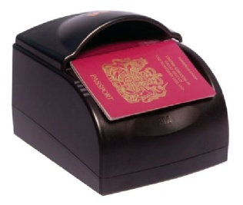

Fingerprint Clocking-in or Registration System (Details)
Input: Fingerprint on sensor
Process:

Output:

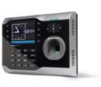
Automatic Windscreen Wiper (Details)
Input:

Process:

Output: Wipers switch on
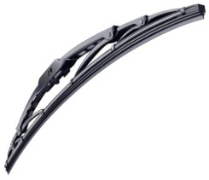

Automatic Smoke Detector (Details)
Input:

Process:

Output:

