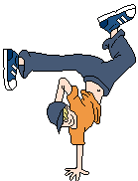 | Break dancer  This project creates a break dancer that moves to a beat. (works best with sound)
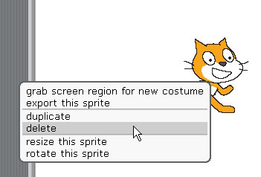 | RIGHT mouse click on the cat and click 'delete'
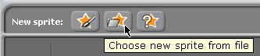 | Click ‘Choose new sprite from file’
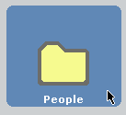 | Double click the ‘People’ folder
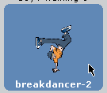 | Click on ‘breakdancer-2’
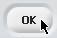 | Click ok.  The sprite will now appear on the stage.
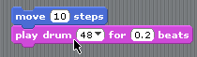 | Add the blocks as shown.  (Motion and Sound)
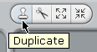 | Click the ‘duplicate’ icon (this is above the ‘stage’).
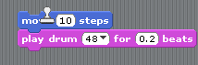 | Click on the BLUE block you’ve just created…
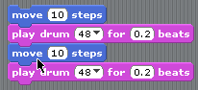 | …drag and snap below.
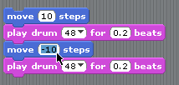 | Change the second ‘move’ block so it reads -10.
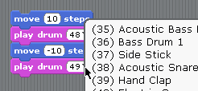 | Change the second drum to another sound of your choice (e.g. Ride Cymbal 2)
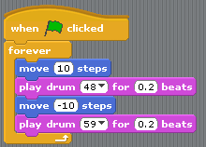 | Add the control blocks as shown.
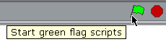 | Click the ‘start’ flag and check out your break dancer!
 | Experiment with changing the drums and the ‘beat’ values.

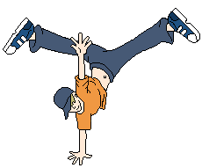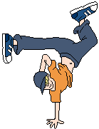 | Now to make it change costume…  Stop your script…
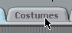 | Click on the ‘Costumes’ tab.
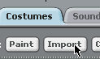 | Click ‘Import’
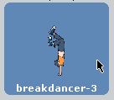 | Import breakdancer-3…click OK.
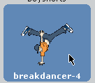 | Do the same again, but import breakdancer-4…
 | …and breakdancer-1.
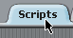 | Click on the ‘Scripts’ tab.
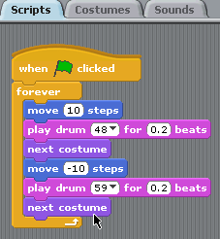 | Click on the ‘looks’ option and then add the blocks as shown.
 | Start your script…check it out!
SAVE YOUR WORK

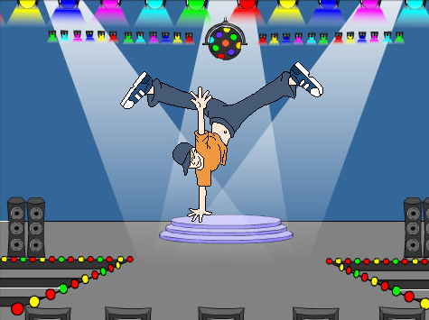 | Adding a background…
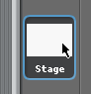 | Click on to the ‘stage’ icon.
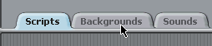 | Click on to the ‘Backgrounds’ tab.
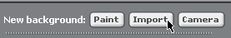 | Click ‘Import’
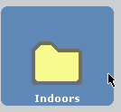… 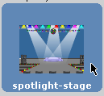… | Double click the ‘Indoors’ folder…  Click the sportlight-stage.  Click ‘ok’.
 | You can click and drag the breakdancer sprite so it’s on the stage.
SAVE YOUR WORK

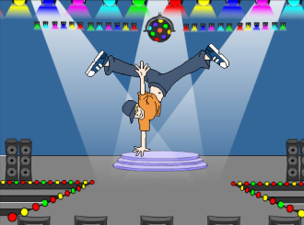 | Adding a music loop
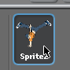 | Click on to the dancer sprite.
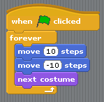 | Adjust the blocks as shown:  (After dragging out blocks, right mouse click and select ‘delete’).
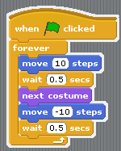 | Add the ‘wait’ blocks and change the number to 0.5.
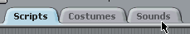 | Click on the ‘Sounds’ tab.
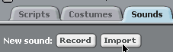 | Click ‘Import’
 | Double click ‘Music Loops’
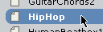… | Click ‘HipHop’  Click ok.
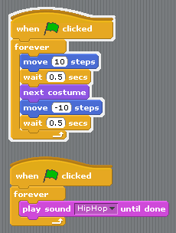 | Add the second set of blocks as shown.
SAVE YOUR WORK
 | Play around with different costumes, number values and music… see what you can create!

